Vocabulary:householdduties
- Write the missing letters to complete the words. Match sentences 1–10 with pictures a–j.
Uzupełnij wyrazy brakującymi literami. Następnie dopasuj zdania 1–10 do rysunków a–j.
  - The man is va _ uu _ ing.
  - She is _ a _ ing the bed.
  - They are doing the _ as _ ing.
  - The woman is i _ o _ ing.
  - Remember to b _ us _ your hair.
  - The boy is w _ s _ ing up.
  - He needs to swee _ the fl _ or.
  - The boy is ge _ ting d _ essed.
  - She is cle _ ning the bat _ room.
10 The woman is d _ s _ ing.
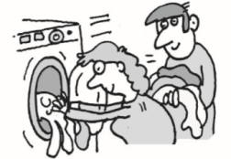a | 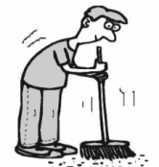 b | 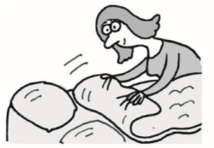c | 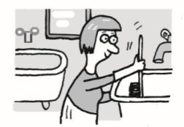d | 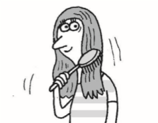e
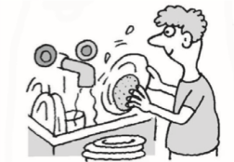f | 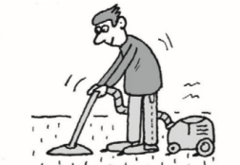g | 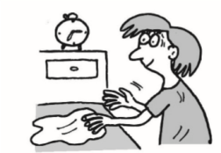h | 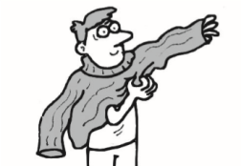i | 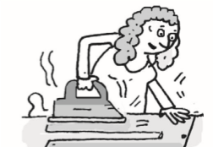j
Score: ___ / 10
- Find five words in each word snake.
Znajdź pięć wyrazów w każdym wężu wyrazowym.
  - h d y s w e e p i n g i l t d r e s s e d y k l c l e a n i n g e s t s h o w e r j c d t i d y a g u
  - s i k f l o o r t a y b r u s h n i g i r o n i n g v l u b r e a k f a s t e d u c a r p e t d a j
Score: ___ / 10

Extra Task
3 Circle the correct option: a, b or c.
Zakreśl poprawną odpowiedź: a, b lub c.
At weekends I often help my parents with the (1) _____. I (2) _____ the floors and (3) _____ the washing up. I don’t like (4) _____, but sometimes my mum asks me to do some. She always tells me to (5) _____ my bed too, but I don’t know why it’s so important.
- a homework b cleanwork c housework
- a vacuum b have c help
- a doing b does c do
- airon b irons c ironing
- a made b make c making

Vocabulary: shopping, money and food
- Write the missing letters to complete the words. Match sentences 1–10 with pictures a–j.
Uzupełnij wyrazy brakującymi literami. Następnie dopasuj zdania 1–10 do rysunków a–j.
  - This is a l _ a _ of bread.
  - This is a c _ _ t _ n of drink.
  - This is a pa _ ke _ of biscuits.
  - This is a tro _ le _.
  - This is a b _ t _ le of water.
  - This is a j _ r of o _ i _ es.
  - This is a _ i _ of to _ atoes.
  - This is a re _ ei _ t.
  - This is a c _ _ of cola.
  - This is a b _ r of c _ oco _ ate.
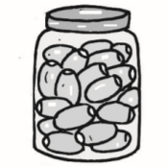 a | 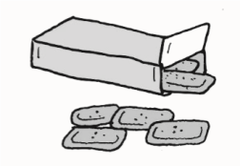b | c | 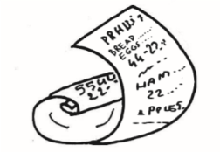d | 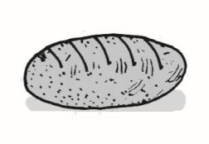e
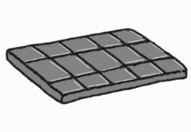f | 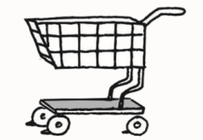g | 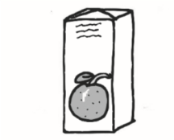 h | 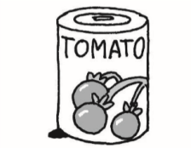i | 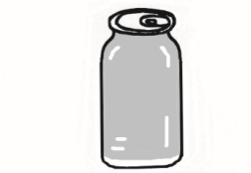j
Score: ___ / 10
- Find five words in each word snake.
Znajdź pięć wyrazów w każdym wężu wyrazowym.
  - u k s l e n d r a s c a s h i e r g u h t i l l e k l b u y f i h j u i c e l a t
  - o k u b o r r o w d o h s a v e t i k s p e n d i c n c u s t o m e r b i j c a s h l u t

Extra Task
3 Circle the correct option: a, b or c.
Zakreśl poprawną odpowiedź: a, b lub c.
I love to (1) _____ every weekend. I visit the local shopping centres and I always (2) _____ a lot of money on clothes and gadgets. I don’t know how to (3) _____ money, so I never have any at home. In fact, I often (4) _____ money from my parents, but they don’t usually ask for it back. This weekend I’m going to buy a jacket that I (5) _____ in the shop last week.

- a going shopping b went shopping c go shopping
- a spending b spend c am spend
- a saves b save c saving
- a borrowed b borrowing c borrow
- a saw b see c seeing
Score: ___ / 5

Grammar: be going to, Future Simple
1 Circle the correct option: a, b or c.
Zakreśl poprawną odpowiedź: a, b lub c.
- I _____ buy a new computer next month.
a going to b will c am going to
- Give me one of the bags. I _____ carry it for you. a will bam going to c am carrying
- She _____ the race. She’s not fast enough.
a is going to win b will win c won’t win
- When _____ his parents about his marks?
a will he tellingb is he going to tellc is he tell
- _____ me with chemistryhomework?
aWill you help b Are you helping c Will you helping
6 She _____ spend a lot of money this weekend. a doesn’t b will be c isn’t going to
- Look at the snow! The bus _____ late.
a will be b is be c is going to be
- OK, I _____ the shopping later when I’ve got some free time.
aam doing b will do c going to do

- Your uncle _____ here at about 5 o’clock.
a is going b is being c will be
- I checked the weather online. It _____ rain tomorrow. a will be b isn’t going to c won’t be

2 Circle the correct option to complete the sentences.
Uzupełnij zdania, zakreślając poprawną odpowiedź.
- Do you think Tom will / is going to pass the exam?
- I’m going play / to play tennis this afternoon.
- She isn’t going to / going invite the boys.
- I’ll meet / meeting you at the railway station.
- I not will / won’t eat any chocolate for a week.
- We are going / going to visit Greece this year.
- Look at those black clouds in the sky! It will / is going to rain.
- Don’t worry. I helped / will help you with your homework.
- I think I will / am going to arrive earlier.
- Come in! I going to / will make some tea.
Score: ___ / 10

Extra Task
3 Put the words in the correct order to make sentences. Then number them to make a dialogue.
Ułóż wyrazy w odpowiedniej kolejności, żeby utworzyć zdania. Następnie ułóż z nich minidialog.
- want / for / you / do / What / it / ?

- next / some / month / money / save / I’ll / .
- blouse / going / a / buy / to / I’m / .
- some / lend / Can / me / money / you / ? 5 give / you / it / will / When / back / ?
Score: ___ / 5

Grammar: countable and uncountable nouns, quantifiers
- Circle the correct option: a, b or c.
Zakreśl poprawną odpowiedź: a, b lub c.
- There is a lot of _____ on the road today. athe traffic b traffic c a traffic  - How _____ children has your sister got? amany b lot c much  - We only have got _____ biscuits.  - a few b few c a little  - Shehasn’tgot _____ luggage.  - some b many c much  - Is there _____ fruit in the bowl?  - none b any c many | - They didn’t give us _____ information.  - many b much c lot of  - There are _____ women in the company. aany b much c a lot of  - They need to buy _____ more equipment. asome b a few c many  - How _____ money have you got?  - much b many c a lot of  - There aren’t _____ tables in the room. a much b no c any
Score: ___ / 10
- Circle the correct option to complete the sentences.
Uzupełnij zdania, zakreślając poprawną odpowiedź.
  - They only gave me a few / a little advice.
  - The company did not do many / much research.
  - How many / much bananas are there on the table?

